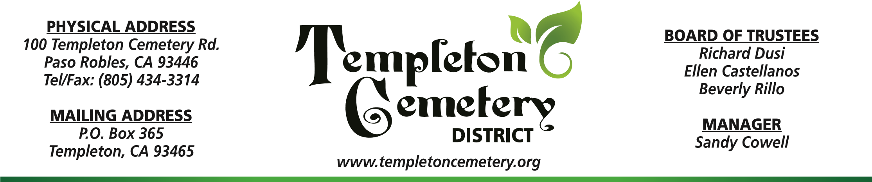
A regular meeting is scheduled for the Templeton Cemetery District on Thursday August 14, 2025 at 4:00 PM. The meeting will be held at the Templeton Cemetery Office located at 100 Templeton Cemetery Road, Paso Robles, Ca 93446. All Health and Safety measures will be observed.

AGENDA:
Call to order
Roll Call
Pledge of Allegiance
Public Comment

Consent Agenda:
Minutes: July 17, 2025

Staff Report

Business:
- July 2025 Financials: The Trustees will review and if no objections to the July Financials, they will then approve the 2025 Financials as presented. (Discussion / Approval).
- Trustee Comments: The Trustees will take this opportunity to voice their comments or concerns. (No action taken)
- Adjournment.

**Members of the public will have the opportunity to direct comments to the Cemetery Trustees during Public Comment and address any items listed on the Agenda before or during consideration of that item. The Templeton Cemetery District complies with the Americans with Disabilities Act and California Government Code 54954.2.

